Countdown Timer / Respawn

To design the countdown timer you must create a game object called “Timer” Under the timer make a Text Canvas and type in the text box “00” this is so you can then adjust the timer in any way you want. Also to make it more neat just give your text a name so you remember.



Next stage is the code to count down. The code holds code for the timer to count down to 0 and the timer to respawn you to any area on the map you want. This will also allow you to adjust your own timer on the side of unity instead of typing it on the script itself.

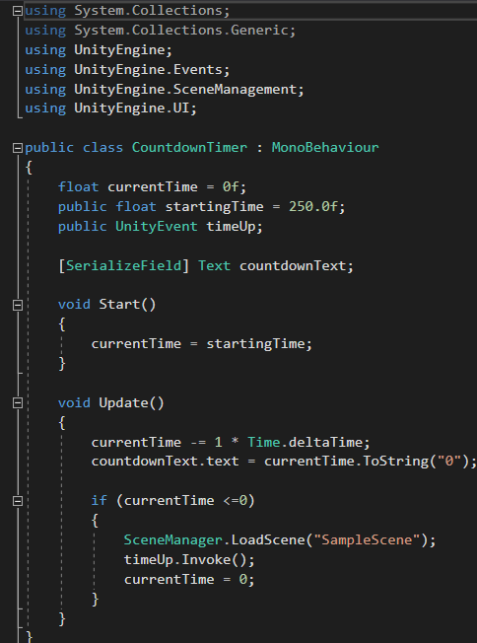

The code also holds a void update that gives you a scene manager for your scene you want to respawn in or you could use Unity.Event as your respawn for different levels.